Editorial Highlights
Technology Record: Issue 31 – Winter 2023

Last editorial contribution date: 13 November 2023
Publication date: 12 December 2023

Upfront
A round-up of technology innovations and business wins from Microsoft and its ecosystem of partners.
Cover story
Feature: Using the cloud to balance rapid success with long-term value
A new generation of cloud-based tools are helping business leaders to future-proof their organisations by streamlining operations and connecting partner, workforce, and customer ecosystems in ways unimaginable only a few short years ago. Advances in the field of artificial intelligence add even greater layers of flexibility to this story of technology migration, which sees enterprise and public sector organisations of every kind moving rapidly toward the cloud. For many, Microsoft’s family of Industry for Cloud offerings, coupled with AI powered solutions like Copilot, provide competitive advantage at lightning speed, and at a scale previously unavailable to the global community of end-users.
- Microsoft spokesperson: To be confirmed.

Special focus
Feature: Exploring the MISA partner ecosystem
Since its inception in 2018, the core vision of the Microsoft Intelligent Security Association (MISA) has been to gather together best-of breed security specialists to develop solutions and services that leverage the Microsoft technology stack. By working with MISA members to integrate their existing solutions and to create completely new security tools using its cloud-based technology, Microsoft has been able to drive the security agenda at pace across all areas of commerce and civic activity. In this special focus feature Technology Record talks with Microsoft leaders and MISA partners about the unique solutions being created through this collaboration.
- Microsoft spokesperson: Maria Thomson, Microsoft Intelligent Security Association Lead.

Financial Services
Feature: Boosting workforce effectiveness to improve customer experiences
From back-office call centres to frontline claims adjuster, financial services organisations depend upon skilled personnel to gain competitive advantage. Workers must be knowledgeable and effective in responding to the needs of their customers, while also generating positive outcomes from every engagement. The workforce is a key asset of any organisation, which is why Microsoft works with its ecosystem of FSI partners to develop tools that empower the worker. Technology Record investigates.
- Microsoft spokesperson: Mayank Verma, senior director of product marketing - Microsoft Teams for Industry & Frontline Workers.
Industrials & Manufacturing
Feature: Using digital twins to accelerate time to market
The concept of digital twins has been a driver for manufacturing innovation for some years; however, with the recent introduction of AI tools, manufacturers are now presented with opportunities to move from gaining insight into known data silos to exploring design and production options that extend far beyond the factory walls. From improving existing industrial processes to designing entirely new product lines, the power of the digital twin as an agent of change is undeniable.
- Microsoft spokespeople: Alfonso Rodriguez, product marketing director, Microsoft Cloud for Manufacturing.

Media & Communications
Feature: Accelerating production at the edge of the network
The media industry is reaching an inflexion point, as cloud and artificial intelligence fuel transformation throughout the sector. Many media organisations are wary about making the move fully into the cloud for a variety of reasons, despite their desire for the capabilities it offers. In this feature, Technology Record will explore the space between the two worlds of on-premises and cloud operations: the edge. We’ll examine what a hybrid approach to the cloud, enabled by edge computing, can offer media organisations and how it can help drive forward efficiency and innovation throughout the industry.
- Microsoft spokesperson: Scott Davis, broadcast media architect.

Public Sector
Feature: Transforming justice and defence services with digital tools
Living in a connected world has obvious advantages, but it also provides those wishing to gain unfair advantage or disrupt daily life with entirely new ways of operating. As cybercrimes continue to rise, law enforcement agencies and justice departments around the world are working to deploy robust and secure counter solutions. Public safety organisations are utilising cloud technology to accelerate their operations, effectively share data across multiple agencies and modernise communications, for workforces and citizens alike.
- Microsoft spokesperson: Kirk Arthur, worldwide government solutions lead.

Retail and Consumer Goods
Feature: Reinventing the world of retail with generative AI
Recent industry surveys suggest that within just a few months of public availability almost 20 per cent of shoppers have already looked to generative AI to assist in making purchase decisions. For retailers the race is now on to embrace new technology to radically overhaul supply chains, storefronts, and customer engagement methodologies. For a growing number, Microsoft cloud solutions are providing the edge required to succeed in this highly competitive sector. We find out more.
- Microsoft spokesperson: Shanthi Rajagopalan, head of solutions sales strategy, worldwide retail and consumer goods.

The last word
Analysis: Views on a digitally transformed world from Technology Record, along with opinions from leading industry analysts and associations.

Event partnership
Throughout the year Technology Record maintains strategic links and a physical presence for both publication and personnel at a number of leading in-person industry events. At the same time, the magazine supports and augments virtual gatherings with digital promotion and online coverage.

Winter 2023 events:
NRF, 14 – 16 Jan, New York  BETT Show, 24 -26 Jan, London  ARC Orlando 2024, 4 – 8 Feb, Orlando  MWC Barcelona, 26 – 29 Feb, Barcelona  E-tail West, 26 – 29 Feb, Palm Springs | EuroCIS, 27 - 29 Feb, Dusseldorf  Days of Knowledge (DoK), 21 – 22 Mar, Birmingham  Shoptalk, 17 – 20 Mar, Las Vegas  Enterprise Connect, 25 – 28 Mar, Orlando  American Manufacturing Summit, TBC, Chicago.

Alliances
Technology Record is proud to partner with a broad range of leading industry organisations including:
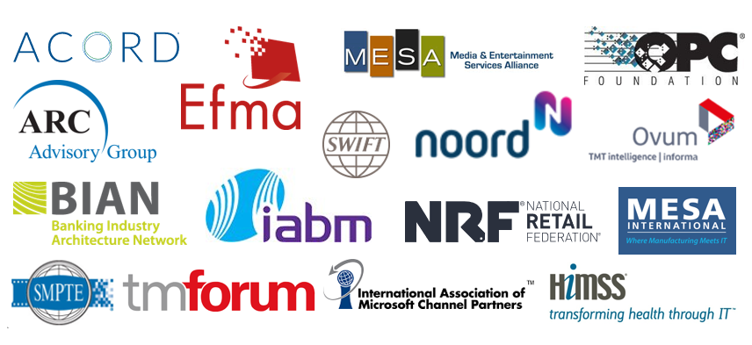

Talk with one of our dedicated industry leads
We are happy to talk with you about forthcoming editorial planning and the wealth of marketing opportunities which are available to Microsoft partners wishing to promote their brand.

Financial Services: Ricky Popat - ricky.popat@technologyrecord.com
Industrials and Manufacturing: Daniel Thurlow - daniel.thurlow@technologyrecord.com
Media & Communications: Tim Grayson - tim.grayson@technologyrecord.com
Public Sector: Paul Zmija - paul.zmija@technologyrecord.com
Retail & Consumer Goods: Thomas Wills - thomas.wills@technologyrecord.com.

Executive editor: Andy Clayton-Smith - andy@technologyrecord.com
Editorial lead: Alice Chambers - alice.chambers@tudor-rose.co.uk
Digital content lead: Amber Hickman – amber.hickman@tudor-rose.co.uk.

Further information
Technology Record is published quarterly by Tudor Rose. To find out more or to view back issues visit www.technologyrecord.com. This editorial plan is subject to the availability of those organisations and individuals listed. Alternative contributors will be found wherever possible.

Find out more at https://www.technologyrecord.com/contact-us.

