Editorial highlights
Technology Record: Issue 38 – Autumn 2025

Last editorial contribution date: 22 August 2025
Publication date: 26 September 2025

Upfront
A round-up of technology innovations and business wins from Microsoft and its ecosystem of partners.

Cover story
Enriching customer experiences
A recent Gartner poll of more than 2,500 executives found that 38 per cent of those questioned believe customer experience and retention is the primary purpose of their generative AI investments. For many, the assumption is that whilst generating new business is a must for any successful organisation, retaining new customers for the long-term has never been so important – and the advent of GenAI is being seen as a key tool to further that aim. For many, choosing Microsoft as the technology provider of choice makes complete sense. Microsoft has integrated generative AI with its long-established solutions like Microsoft Office and Dynamics to evolve the ways in which organisations connect products and workforces with their customers.
- Microsoft spokesperson: Pamela Maynard, chief AI transformation officer, Microsoft customer and partner solutions.



In focus
Microsoft Dynamics 365 and Copilot as agents for change
The Microsoft Dynamics story has roots which reach back almost two decades, during which time the solutions it contains have established themselves as key components of both enterprise and public sector operations worldwide. This cloud-enabled platform, which integrates CRM and ERP capabilities to power both business processes and customer relationships, already commands a significant proportion of the global technology market. With the integration of Microsoft Copilot, users from all walks of life are witnessing fundamental shifts in the way their organisations structure themselves. In this special feature, Technology Record takes a closer look at the broad spectrum of solutions and services which Microsoft and its ecosystem of partners are delivering, and the ways in which these new tools are boosting productivity and profitably across increasingly challenging markets.
Financial Services
Feature: Evolving core systems within FSI
For bankers and insurers alike, core systems such as account management, policy administration, transaction processing, underwriting, claims processing, and customer relationship management are an essential part of daily operations. Add to this a trading environment increasingly beset by industry regulation and it is no wonder that financial services industry leaders look to cloud based and generative AI tools to drive operations, grow customer bases, and maximise profits. Microsoft has a substantial heritage of providing industry-leading solutions for the FSI industry and, as business leaders prepare to gather in at this year’s Sibos event in Frankfurt, Technology Record takes a closer look at how tools like the Microsoft’s Cloud for Financial Services and Copilot are driving positive change.
- Microsoft spokespeople: Tyler Pichach, head of worldwide banking strategy / Dalia Ophir, director of business strategy, worldwide financial services, insurance.

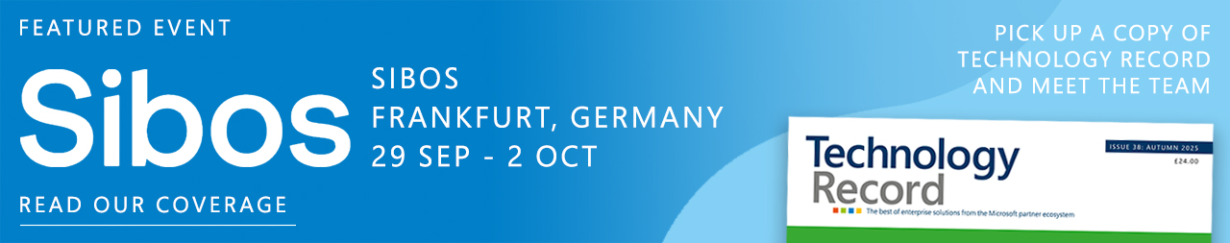

Industrials & Manufacturing
Feature: Enabling new products through innovation
Manufacturing is at a crossroads, where traditional processes and operating models are being rapidly overhauled to keep up with the pace of change that modern customers and global markets demand. Now more than ever, the ability to innovate and to rapidly evolve is key to survival, and for those manufacturers that can scale and flex with a level of agility, the potential rewards are enormous. Adopting technology to enable new ways of looking at how products are designed and delivered has never been as vital to business success. For many, tools like Microsoft’s Cloud for Manufacturing, GenAI solutions like Copilot, and digital twins powered by Azure Cloud are proving to be a game changer when it comes to new product research, design and launch. We take a closer look.
- Microsoft spokesperson: John Chien, director, industry and product marketing.



Media & Communications
Feature: The role of data in the media operations – what’s changing the game?
High-quality data has always been the backbone of media and entertainment workflows. That’s not new but what has changed is the scale, speed, and expectation around how that data is used. Whether businesses are conducting audience research, building segmentation models, or launching targeted campaigns, nothing works without clean, connected, and well-structured data. The same goes for personalising content or optimising ad placements – all these efforts fall flat without a strong data foundation. The success of nearly every strategic initiative in media today, from monetisation to engagement, depends on how effectively organisations harness their data. Technology Record finds out more.
- Microsoft spokesperson: James Parker-Barrett strategy director, media and entertainment industry.



Public Sector
Feature: Driving public sector innovation at pace and scale.
As Microsoft’s Public Sector team prepares for this year’s Smart City Expo World Congress gathering in Barcelona, Technology Record takes a look the latest advances in the solutions and services empowering cities around the world. We explore how cloud, AI and other technologies from Microsoft and its partners are helping leaders to enable intelligent citizen services, build tech-empowered cities, boost operational resiliency and optimise public safety and emergency response. In addition, we highlight how focusing on these four overarching priorities is enabling governments to enhance overall service delivery and improve the quality of life for every individual living and working in urban environments.
- Microsoft spokesperson: Doug Priest, worldwide public transportation and urban infrastructure lead.



Retail and Consumer Goods
Feature: Revenue Growth Management as a driver for profits and success
Increasing numbers of consumer goods businesses are looking to Revenue Growth Management (or RGM) to streamline processes and anticipate ever-evolving customer preferences. By adopting advanced analytics tools to identify activities at store-level, all the way back through the supply chain to the manufacturing plant, CPG retailers can gain valuable insights into the way in which their businesses are operating, where improvements can be made and where new markets can be opened-up. As in other industries, generative AI is playing an increasingly important role, with Microsoft solutions such as Copilot moving taking decision-making from the highly specialised few and broadcasting the ability to add value across the organisation.
- Microsoft spokesperson: Dina Zhou, executive director, industry advisory, retail and consumer goods.

The last word
Analysis: Views on a digitally transformed world from Technology Record, along with opinions from leading industry analysts and associations. In this issue we hear from Louisa Barker, senior research manager at IDC.



Event partnership
Throughout the year Technology Record maintains strategic links and a physical presence for both publication and personnel at a number of leading in-person industry events. At the same time, the magazine supports and augments virtual gatherings with digital promotion and online coverage.

Autumn 2025 events:
SIBOS 29 Sep - 2 Oct, Frankfurt | Money 20/20 USA 16-29 Oct, Las Vegas
GITEX Global 13-17 Oct, Dubai | ADIPEC 3-6 Nov, Abu Dhabi
Smart Retail Tech Expo 15-16 Oct, Las Vegas | Directions EMEA 4-6 Nov, Poznan
South Coast Summit 17-18 Oct, London | Smart Retail Tech Expo (UK) 12-13 Nov, London
Community Summit (NA) 19-23 Oct, Orlando | SCEWC 2025 4-6 Nov, Barcelona
Microsoft Ignite 17-21 Nov, San Francisco | ESPC 1-4 Dec, Dublin.

Members of the Technology Record team will be attending this year’s Microsoft Ignite event in San Francisco. Contact us now if you would like to meet the team at Ignite 2025.

Alliances
Technology Record is proud to partner with a broad range of leading industry organisations including:

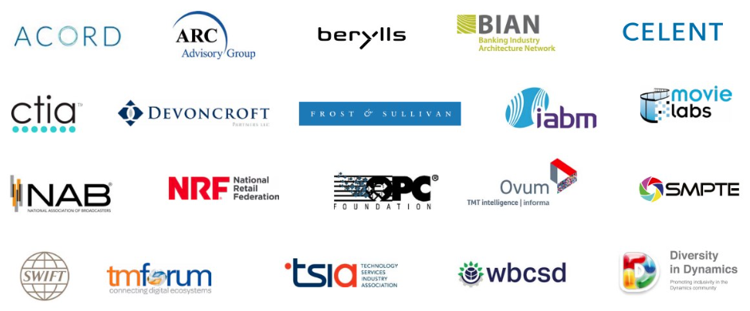

Find out more about how to leverage Technology Record
Contact us about the wealth of marketing opportunities available to Microsoft partners looking to promote their brand:

Advertising and sponsorship: Ricky Popat - ricky.popat@technologyrecord.com

Executive editor: Andy Clayton-Smith - andy@technologyrecord.com
Editorial lead: Alice Chambers - alice.chambers@tudor-rose.co.uk
Digital content lead: Amber Hickman - amber.hickman@tudor-rose.co.uk

Further information
Technology Record is published quarterly by Tudor Rose. To find out more or to view back issues visit www.technologyrecord.com. This editorial plan is subject to the availability of those organisations and individuals listed. Alternative contributors will be found wherever possible.

