Editorial highlights
Technology Record: Issue 42 – Autumn 2026

Last editorial contribution date: 19 August 2026
Publication date: 28 September 2026

Upfront
A round-up of technology innovations and business wins from Microsoft and its ecosystem of partners.

In conversation with
As part of our ongoing series of interviews with senior leaders at Microsoft, we talk with corporate vice president and chief operating officer, global enterprise sales, Lloyd Adams.



Cover story
Managing change in the workplace to power customer delight
For as long as industry and civic organisations have been leveraging technology to manage core processes, leaders have been faced with the challenge of delivering excellent customer service while managing the overall cost of operations. In more recent times, it seems that the promise of genuinely game-changing advances to automate processes and free-up the workforce to concentrate on delivering more intuitive, highly personalised and ‘human’ services are being powered by the rapid evolution of agentic AI. For Microsoft, tools like Azure, Copilot, Dynamics, Teams and Office are key to the way in which businesses and public sector service providers can transform their customer experiences, not only to offer genuine customer delight but to power real growth and competitive advantage. We take a closer look in this Autumn issue of the magazine.
- Microsoft spokesperson: Shelley Bransten, corporate vice president, intelligent cloud and global industry solutions.


In focus
Dynamics 365 – the common link between supply chain, operations and commerce
Over 20 years since its launch as a unified offering, Microsoft Dynamics has gone on to become the de-facto solution for organisations looking to tackle barriers which previously held them back. By adopting this burgeoning suite of tools to power ERP and CRM processes, businesses of all sizes are discovering new ways to connect workforces, reach new markets and deliver more agile services, at speed and scale. The arrival of fully embedded agentic AI within these solutions is set to revolutionise the way in which modern businesses operate, as many early adopters have already discovered. In this special feature, Technology Record offers insight into latest iterations of this near-ubiquitous suite of productivity tools and showcases work being done by customers across all sectors.
- Microsoft spokesperson: Sameer Verma, vice president and chief product officer, Dynamics 365 AI ERP (to be confirmed).



Financial Services
Maximising payments and core systems efficiency
Agentic AI continues to radically overhaul the way that traditional back-office processes are delivered, with banks drawing increased value from more structured data, while discovering new and exciting ways to interact with clients. They are also streamlining workflows to enable smoother, more cost-effective operations in an operational environment subject to ever-greater levels of regulatory oversight and corporate responsibility. AI-powered tools from Microsoft are allowing financial services organisations to innovate at pace whilst allowing their workforces to divert attention toward delivering more insightful customer outcomes. We find out how.
- Microsoft spokesperson: Tyler Pichach, global head of AI strategy and GTM. payments and banking.



Industrials and Manufacturing
New tools to evolve the manufacturing supply chain
The adoption of AI tools across the operational landscape offers manufacturers tangible improvements, nowhere more so than in the areas of supply chain and inventory management. By automating large swathes of repetitive, often low-value tasks traditionally associated with supply chain management, AI tools can help manufacturers improve day-to-day operations and enable more agile production practices throughout their organisations. The optimisation of supply chain with AI tools is allowing business leaders two find new ways of accurately forecasting demand, improving their delivery times, and lowering cost.
- Microsoft spokesperson: Bindu Pillai. product marketing lead, supply chain.

Media and Communications
Maximising audience data to gain real market share
Many within the media and entertainment community have already concluded that data is their new, transformational currency. Those engaged in developing cutting-edge solutions, whether by delivering highly personalised consumer experiences via agentic AI personas, or generating entire interactive, persistent worlds across multiple formats and platforms, know that the story begins and ends with data. Digital or physical, a company’s legacy data holds the key to competitive advantage. So what are the tools that media and entertainment leaders are leveraging to monetise this data goldrush?
- Microsoft spokesperson: Simon Crownshaw, CTO and worldwide strategy director for media & entertainment.



Public Sector
Using technology to deliver public infrastructure wins
Cities around the world are adopting a ‘system-of-systems’ approach to their planning activities. By integrating data drawn from energy, environmental, housing, transport, and services silos, complex AI-powered modelling and forecasting is allowing civic leaders to gain insight more rapidly and make decisions more dynamically. Microsoft and its ecosystem of public sector partners are providing AI-powered tools and services to help civic leaders to move from reactive organisation to more proactive and efficient methodologies. This, in turn, drives more informed decision making and greater resilience across the entire city landscape.
- Microsoft spokesperson: Doug Priest, worldwide public transportation and urban infrastructure lead.

Retail and Consumer Goods
Beyond digital: How AI and partnerships are redefining retail and consumer goods
As margins tighten and labour remains scarce, the next competitive reset will not happen in dashboards but on the physical edge. After a decade of digitising, planning, and leveraging analytics tools, retailers now face structural volatility, rising service expectation, and an unreliable workforce availability. Incremental forecasting gains are no longer enough. By connecting cloud intelligence to execution on the shop floor and in the aisle, Physical AI enables operations to run with software-like speed, resilience, and discipline, reshaping cost-to-serve metrics and service performance.
- Microsoft spokespeople: Felice Miller, global business strategy lead, retail and consumer goods / ShiSh Shridhar, global director, retail and consumer packaged goods start-ups.



The last word
Commentary on a digitally transformed world from Technology Record, along with opinions from leading industry analysts and associations.

Event partnership
Throughout the year Technology Record maintains strategic links and a physical presence for both publication and personnel at a number of leading in-person industry events. At the same time, the magazine supports and augments virtual gatherings with digital promotion and online coverage.

Autumn 2026 events:
Sibos 28 Sep – 1 Oct, Miami | SCEWC 2026 3-5 Nov, Barcelona
Money 20/20 USA 18-21 Oct, Las Vegas | Cybersecurity Congress 3-5 Nov, Barcelona
Tech Expo Europe 20-21 Oct, Amsterdam | Smart Retail Tech Expo 11-12 Nov, London
Community Summit 11-15 Oct, Nashville | Microsoft Ignite 17-20 Nov, San Francisco
Power Platform Conference 27-29 Oct, Vegas | ESPC 30 Nov - 3 Dec, Amsterdam
Directions EMEA 27-29 Oct, Paris | GITEX Global 7-11 Dec, Dubai
ADIPEC 2-5 Dec, Abu Dhabi | Convergence 365 8-11 Dec, Miami.

Alliances
Technology Record is proud to partner with a broad range of leading industry organisations including:

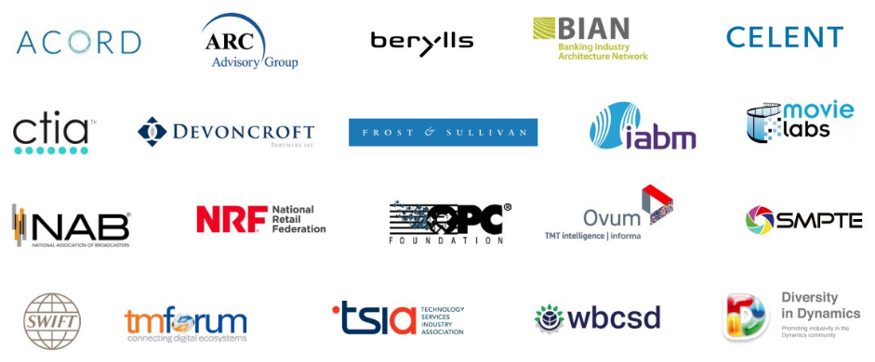

Find out more about how to leverage Technology Record
Contact us about the wealth of marketing opportunities available to Microsoft partners looking to promote their brand:

Executive editor: Andy Clayton-Smith - andy@technologyrecord.com
Advertising sales enquiries: Ricky Popat - ricky.popat@technologyrecord.com.

Further information
Technology Record is published quarterly by Tudor Rose. This editorial plan is subject to the availability of those organisations and individuals listed. Alternative contributors will be found wherever possible.

