Editorial highlights
Technology Record: Issue 40 – Spring 2026

Last editorial contribution date: 19 February 2026
Publication date: 30 March 2026

Upfront
A round-up of technology innovations and business wins from Microsoft and its ecosystem of partners.



In conversation with
As part of our ongoing series of interviews with senior leaders at Microsoft, we talk with corporate vice president of global manufacturing and mobility, Dayan Rodriguez, about the way ahead for Microsoft in manufacturing during the coming year.



Cover story
Maintaining and growing security in an AI-enabled world
As early adopters of latest technology solutions will know, successful implementation of AI depends upon colossal amounts of data to operate effectively, with many AI tools being embedded deeply into legacy workflows and data silos. While the benefits are significant, so is the potential for data being left open to abuse or outright attack in ways previously thought impossible, which is why security, regulation, and governance has become such a hot topic for this space. The rapidly evolving array of security and compliance tools being offered by Microsoft and its ecosystem of partners can enable phased, highly controllable Zero Trust principles to be rolled out across enterprise and public sector organisations with relative ease. We take a closer look at this key topic of responsible and secure AI adoption.
- Microsoft spokesperson: Jessica Hawk, corporate VP Microsoft data, AI and digital applications product marketing (to be confirmed).


Financial Services
Feature: Laying the foundations of frontier insurance with agentic AI
Frontier insurance is the next evolution of the industry, where insurers are able to move beyond digitisation and automation to embrace new operating models that are powered by human–agent collaboration. In a frontier firm, AI agents are not just tools; they are digital colleagues, that work alongside existing workforces to transform every stage of the insurance value chain. From actuarial and underwriting, to customer retention and claims management, AI-powered solutions from Microsoft and its community of FSI partners are accelerating the pace of change across the entire operational landscape of insurance and reassurance. We find out how.
- Microsoft spokesperson: To be confirmed.



Industrials & Manufacturing
Feature: The need for operational technology security
Outside of a manufacturing environment, the term Operational Technology (or OT) security may hold very little resonance; however, for those charged with managing a wide array of legacy, ‘pre-cloud’ industrial devices and ensuring they operate securely and reliably as part of an increasingly interconnected manufacturing ecosystem, OT security can pose real problems. Ever greater numbers of industry leaders are turning to tools within the Microsoft Cloud for Manufacturing family to address these issues, with products like Azure, Defender, and Sentinel taking the lead in securing legacy solutions and making them ready for an AI-enabled future. We find out more.
- Microsoft spokesperson: Indranil Sircar, CTO, manufacturing and mobility industry.


Media & Communications
Feature: Reimagining the media world with new data and AI tools
The rapid change of content delivery and customer engagement in the media arena makes the industry an obvious candidate for the adoption of new technology. By using AI-powered tools to analyse data, whilst at the same time harnessing the power of the cloud to create, manage, and deliver content across a host of platforms, media organisations are maximising revenue share by offering highly personalised customer experiences in ways which will rewrite the engagement playbook. This issue of Technology Record examines how Microsoft AI tools are fundamentally changing the way in which media companies operate and engage with consumers.
- Microsoft spokesperson: To be confirmed.



Public Sector
Feature: Delivering meaningful healthcare outcomes
AI-powered solutions are helping clinicians and care providers across multiple competencies to innovate, by using new tools to increase personal productivity, accelerate the scope and reach of research, and provide measurable improvement in a broad variety of clinical outcomes. At the same time, cloud and AI-enabled solutions from Microsoft and its ecosystem of healthcare partners are helping secure clinical data at a point where interconnectivity and information sharing is going through a phase of exponential growth. Microsoft products and know-how are helping healthcare professionals worldwide to improve the services they can offer to patients.
- Microsoft spokesperson: Dr David Rhew, global chief medical officer and VP of healthcare (to be confirmed).

Retail and Consumer Goods
Feature: Accelerating innovation across the value chain to drive brand value
Retailers of every kind are learning that the tricky business of ‘speed to shelf’ has shifted from being a potential advantage to an absolute necessity. Consumer goods leaders face demand volatility, sustainability mandates, and omnichannel complexities that make end-to-end acceleration across the value chain essential. From concept to consumer, compressing time to shelf reinforces brand relevance, drives loyalty, and unlocks growth. For many, the technology tools which Microsoft and its ecosystem of industry partners provide can make the essential difference between being a market competitor and the clear industry leader. We take a closer look in this latest issue of Technology Record.
- Microsoft spokesperson: Felice Miller, global business strategy lead, retail and consumer goods.
The last word
Analysis: Views on a digitally transformed world from Technology Record, along with opinions from leading industry analysts and associations.

Event partnership
Throughout the year Technology Record maintains strategic links and a physical presence for both publication and personnel at a number of leading in-person industry events. At the same time, the magazine supports and augments virtual gatherings with digital promotion and online coverage.

Spring 2026 events:
NAB SHOW  18–22 Apr, Las Vegas  Hannover Messe  20–24 Apr, Hannover  DTX and UCX  29–30 Apr, Manchester  European Collaboration Summit  05–07 May, Cologne  AI Everything Global  11–13 May, Abu Dhabi  DynamicsCon  12-5 May, Las Vegas  Tech Expo North America  18–19 May, San Jose, California  HIMSS Europe  19–21 May, Copenhagen  European Power Platform Conference  01–04 Jun, Copenhagen | Money 2020 Europe  02–04 Jun, Amsterdam  InfoSecurity Europe  02–04 Jun, London  GITEX Central Asia & Caucasus  02-04 Jun, Kazakhstan  London Tech Week  08–12 Jun, London  InfoComm  13–19 Jun, Las Vegas  Identiverse  15–18 Jun, Las Vegas  Commsverse  24–25 Jun, London  GITEX EUROPE  30 Jun–01 Jul, Berlin.

Alliances
Technology Record is proud to partner with a broad range of leading industry organisations including:
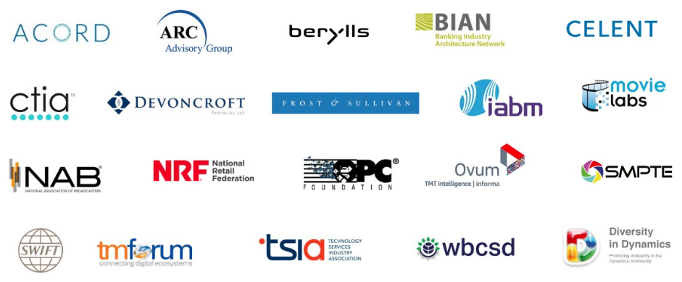

Find out more about how to leverage Technology Record
Contact us about the wealth of marketing opportunities available to Microsoft partners looking to promote their brand:

Executive editor: Andy Clayton-Smith - andy@technologyrecord.com
Editorial lead: Alice Chambers - alice.chambers@tudor-rose.co.uk

Advertising and sponsorship: Ricky Popat - ricky.popat@technologyrecord.com

Further information
Technology Record is published quarterly by Tudor Rose. To find out more or to view back issues visit www.technologyrecord.com. This editorial plan is subject to the availability of those organisations and individuals listed. Alternative contributors will be found wherever possible.

