Editorial Highlights
Technology Record: Issue 33 – Summer 2024

Last editorial contribution date: 17th May 2024
Publication date: 25th June 2024

Upfront
A round-up of technology innovations and business wins from Microsoft and its ecosystem of partners.

Cover story
Feature: Enriching workplace culture with new technologies.
The largest investments in any organisation have traditionally been made in infrastructure and equipment; however, a growing number of industry leaders are discovering that tangible wins can also come from creating a motivated, committed workforce which is empowered, connected and productive – and also able to thrive in a culture of inclusivity and accessibility.
Organisations of every kind are turning to new technology to help reimagine their traditional workplace environments and to create spaces which will allow workers to automate more mundane and repetitive tasks, releasing time to address higher value operations that will drive the business forward. The cloud lies at the heart of these technology-driven changes and with the recent arrival of generative AI, enterprise and public sector organisations around the world are set to redefine their compact with personnel, ensuring that the world of work is rewarding and productive.
Microsoft spokesperson: To be confirmed.

Special focus
Roundtable: Empowering women in technology.
Technology Record explores some of the reasons behind the underrepresentation of women in the technology industry, how the landscape is evolving to combat this and why diversity plays a crucial role in driving the development of new tools and solutions. We speak with representatives from Microsoft, a women in technology networking association and leading market intelligence providers to hear how businesses can become more gender-diverse.
Roundtable spokespeople: To be confirmed.

Financial Services
Feature: Risk management, compliance and cybersecurity in the financial services industry.
The requirement upon financial services operators to accurately manage risk in a highly security conscious and compliance-led environment is a constant challenge. Organisations need to simplify the ways in which they analyse risk profiles whilst, at the same time, finding ways to seamlessly integrate that work into a broader framework of security and compliance. Many financial institutions will look at Microsoft’s cloud offerings to drive innovation and strengthen cybersecurity in this highly regulated environment.
- Microsoft spokesperson: Tom Deprins, director, Microsoft global financial services regulatory compliance.

Industrials & Manufacturing
Feature: Empowering workers and connecting customers in entirely new ways.
As manufacturers respond to the changing demands of modern markets and workforces, a growing number of industry leaders are actively investing in technology to enable greater collaboration, communication and productivity across their organisations. These new cloud-based tools can enrich the individual employee work experience, address key issues of knowledge transfer and worker retention, whilst also driving productivity and addressing the ever-present issue of changing customer expectations. Technology Record takes a closer look.
- Microsoft spokesperson: Alfonso Rodriguez, director product marketing, Microsoft Cloud for Manufacturing.

Media & Communications
Feature: The importance of an active archive.
Digital transformation runs across all sectors, but probably no community has seen greater impact than those within the media and entertainment industry. With further growth being forecast across all regions of the global media storage market, industry leaders are rapidly rethinking traditional ideas on data archiving and retrieval. For those investing in cloud-based ‘active archives’ the key benefits of accessibility, scalability and security are further enhanced with a manageable cost base for ever-growing collections of content. Microsoft’s Azure Cloud and the range of AI tools being developed for the media industry by Microsoft and its ecosystem of partners are leading the way in this archival revolution.
- Microsoft spokesperson: Andy Beach, CTO, worldwide media and entertainment.

Public Sector
Feature: Delivering on the promise of intelligent transportation.
Civic leaders around the world are tasked with developing public transportation systems that are efficient, accessible and sustainable. Additionally, there is a requirement to ensure efficient flows of personal transportation around the city landscape, along with the effective provision of a range of services associated with the travel choices of both resident and visitor alike. Microsoft technologies are powering the exchange of data in public sector transport logistics, whilst also enabling more efficient operations through automated, data-driven decision making across all forms of city travel.
- Microsoft spokesperson: Doug Priest, public transportation lead, worldwide government.

Retail and Consumer Goods
Feature: Finding new ways to empower retail people.
KPMG UK’s December 2023 Retail Think Tank proposed that in 2024 “generative AI will move from hype to happening and deliver measurable benefits”. The most visible sign of this new technology’s arrival will be in the way that organisations empower their greatest asset – the retail workforce. Equipping workers with solutions to improve productivity and customer satisfaction is just the start of this journey. Cloud platforms used in conjunction with AI-powered tools like Microsoft Copilot can automate time-intensive tasks whilst, at the same time, generative AI can help retailers manage employee deployment and turnover by providing greater insight into the flow of work across the entire organisation.
- Microsoft spokesperson: Anya Minbiole, global business strategy lead, worldwide retail and consumer goods.

The last word
Analysis: Views on a digitally transformed world from Technology Record, along with opinions from leading industry analysts and associations.

Event partnership
Throughout the year Technology Record maintains strategic links and a physical presence for both publication and personnel at a number of leading in-person industry events. At the same time, the magazine supports and augments virtual gatherings with digital promotion and online coverage.

Summer 2024 events:
ARC Asia 10-11 July, Bangalore
IBC 13-16 September, Amsterdam
ITS World Congress 16-20 September, Dubai
Microsoft Power Platform Conference 18-20 September, Las Vegas
DTX / UC Expo, 2-3 October, London
Generative AI week, 7-9 October, London
Alliances
Technology Record is proud to partner with a broad range of leading industry organisations including:
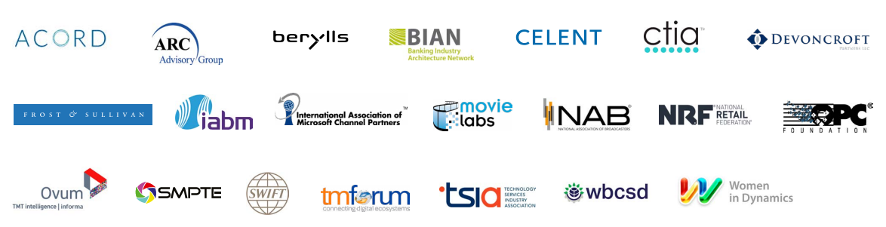

Talk with one of our dedicated industry leads
We are happy to talk with you about forthcoming editorial planning and the wealth of marketing opportunities which are available to Microsoft partners wishing to promote their brand.

Financial Services: Ricky Popat - ricky.popat@technologyrecord.com
Industrials and Manufacturing: Daniel Thurlow - daniel.thurlow@technologyrecord.com
Media & Communications: Tim Grayson - tim.grayson@technologyrecord.com
Public Sector: Paul Zmija - paul.zmija@technologyrecord.com
Retail & Consumer Goods: Thomas Wills - thomas.wills@technologyrecord.com.
Cross-industry: Martin Hall - martin.hall@technologyrecord.com

Executive editor: Andy Clayton-Smith - andy@technologyrecord.com
Editorial lead: Alice Chambers - alice.chambers@tudor-rose.co.uk
Digital content lead: Amber Hickman - amber.hickman@tudor-rose.co.uk.

Further information
Technology Record is published quarterly by Tudor Rose. To find out more or to view back issues visit www.technologyrecord.com. This editorial plan is subject to the availability of those organisations and individuals listed. Alternative contributors will be found wherever possible.

Find out more at https://www.technologyrecord.com/contact-us.

