Editorial highlights
Technology Record: Issue 41 – Summer 2026

Last editorial contribution date: 20 May 2026
Publication date: 29 June 2026

Upfront
A round-up of technology innovations and business wins from Microsoft and its ecosystem of partners.

In conversation with
As part of our ongoing series of interviews with senior leaders at Microsoft, we talk with corporate vice president of public sector, Philippe Rogge, about the ways in which Microsoft and its ecosystem of partners are bringing positive change to government, healthcare, and education organisations worldwide.



Cover story
Empowering workers to thrive while delivering more
Organisations across all sectors are adopting AI to power change. In a keynote speech at the 2025 Consumer Electronics Show, Nvidia CEO, Jensen Huang, posited that AI agents would create a “multi-trillion-dollar opportunity” and this prediction is seemingly being confirmed daily by ‘Frontier firms’ that are leading the AI adoption race. Examples abound. In the financial services industry agentic AI is being used to automate core business functions, detect fraud, and manage compliance across a range of complex workflows. Likewise in the retail sector, new and innovative AI tools are increasingly being used to power personalised customer experiences, whilst at the same time enabling greater levels of automation in key processes such as merchandising and supply chain control. Similar changes can be seen across every industry; however, one vital challenge has still to be fully addressed - along with bringing about process improvement and new-found economies of scale, how can agentic AI enrich individual worker experience whilst elevating entire workforces to greater levels of success? Technology Record takes a closer look.
- Microsoft spokesperson: Kathleen Mitford, corporate vice president, global industry marketing.

In focus
Copilot – sharing the journey so far
Launched in February of 2023 as the natural successor to Microsoft’s ‘virtual assistant’ product, Cortana, the rise of Microsoft’s first generative AI chatbot has been phenomenal to say the very least. Built initially to leverage OpenAI platform, this Large Language Model (LLM) powered AI tool has grown from personal assistant to ‘virtual coworker’, one that is fundamentally changing how its users approach their daily work and the ways in which they collaborate with colleagues, suppliers, and customers. In this special feature we look at how much ground this truly revolutionary tool has covered in the short time since its inception and offer a snapshot of the advances that are promised for the future.
- Microsoft spokesperson: To be confirmed.

Financial Services
Feature: Managing risk and compliance functionality
The financial services sector is evolving rapidly, with innovation powered by AI tools transforming the ways in which organisations are improving their decision-making processes, managing risk, and ensuring consistent compliance in an ever-changing regulatory landscape. Microsoft’s Azure platform provides customers with multi-layered, end-to-end security, compliant with industry frameworks such as the Digital Operational Resilience Act (DORA), and tools like Azure AI Foundry enable the speedy development of solutions that can enhance both agility and resilience for all. We find out more.
- Microsoft spokesperson: Bastian Bahnemann, financial services industry compliance & business development lead.

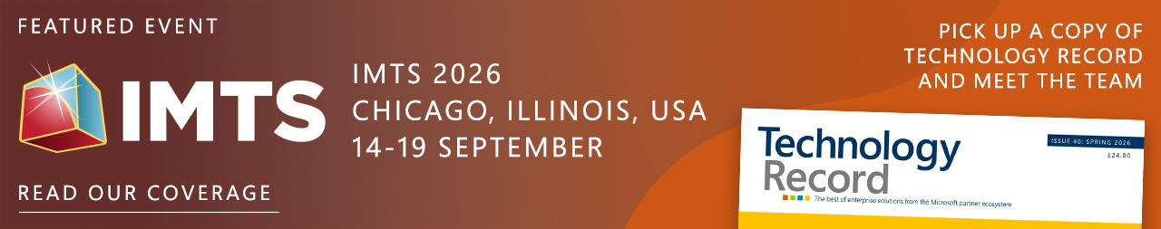

Industrials and Manufacturing
Feature: Accelerating industrial robotics value
The introduction of robotics to manufacturing stretches all the way back to the 1960s, when General Motors introduced the ‘Unimate’ system to its car plant in New Jersey. Since then, manufacturers have constantly leveraged robotic solutions to drive efficiency, whilst taking advantage of the inherent benefits of replacing people in hazardous or toxic working environments. With the advent of AI, industrial robotics is on the cusp of another revolution, as organisations like Microsoft and its ecosystem of partners provide new ways to analyse data, learn from previous experiences, and operate equipment with a level of true autonomy.
- Microsoft spokesperson: John Chien, director, industry and product marketing.


Media and Communications
Feature: Reimagining network operations to tackle hyperscale challenges
In fast-paced industries such as Telecommunications, large or ‘hyperscale’ organisations like Microsoft are poised to redefine how traditional businesses operate. Telco organisations must place technology and innovation at the heart of their future operations to tap-into this hyperscale capacity, to attain the pace, scale, and a flexibility to outstrip traditional hardware-centric infrastructures. Wide scale adoption of cloud and AI solutions will offer operators entirely new ways to drive cross-organisational process improvement, whilst finding new ways to engage with customers, increase existing market share, and transition into new and entirely untapped markets. Technology Record finds out more.
- Microsoft spokesperson: Rick Lievano, chief technical officer, worldwide telecommunications industry.



Public Sector
Feature: Transforming government administration with AI tools
From urban infrastructure planning to collecting taxes, the administrative requirements of any government are truly colossal. Along with ensuring that core citizen services are maintained, front of mind for most public sector leaders worldwide is the challenge of delivering more for less, at a time when citizens expect greater visibility of the work being done on their behalf, and further flexibility in the ways they communicate with public servants. Technology has always been at the heart of government innovation but with the availability of Cloud and AI tools as enablers, many are looking at ways in which enhanced public interactions can sit comfortably alongside compliant, secure, and highly streamlined administration workflows.
- Microsoft spokesperson: Dan Narloch, worldwide government product marketing lead



Retail and Consumer Goods
Feature: The art of merchandising meets the science of agentic intelligence
The art of merchandising has always been rooted in creativity, intuition and a deep understanding of the customer. Today, agentic intelligence is amplifying that craft and releasing merchants and planners from manual, fragmented work, and helping them to focus on creative decisions - shaping assortments, telling product stories and curating ranges that resonate. Simultaneously, these agents ingest real-time signals from across the business and market, enabling merchants to spot emerging trends and respond with greater speed and precision. By combining human imagination with live, data-driven intelligence, agentic workflows are supercharging merchandising as both an art and a science—more fluid, more responsive, and better equipped to drive growth, margin, and relevance in a rapidly changing retail landscape.
- Microsoft spokesperson: Sue McMahon, global strategy director, merchandising & revenue growth.


The last word
Commentary on a digitally transformed world from Technology Record, along with opinions from leading industry analysts and associations.

Event partnership
Throughout the year Technology Record maintains strategic links and a physical presence for both publication and personnel at a number of leading in-person industry events. At the same time, the magazine supports and augments virtual gatherings with digital promotion and online coverage.

Summer 2026 events:
ARC Asia Forum 09 - 10 Jul, Bangalore | Smart Retail Tech Expo 23 - 24 Sep, Las Vegas
ARC Asia Forum 28 Aug, Singapore | Microsoft Fabric SQL 28 Sep - 01 Oct, Barcelona
IBC Sep 11 - 14 Sep, Amsterdam | ITC Vegas 29 Sep - 01 Oct, Las Vegas
IMTS 14 - 19 Sep, Chicago | DTX and UC Expo 14 - 15 Oct, London

Alliances
Technology Record is proud to partner with a broad range of leading industry organisations including:
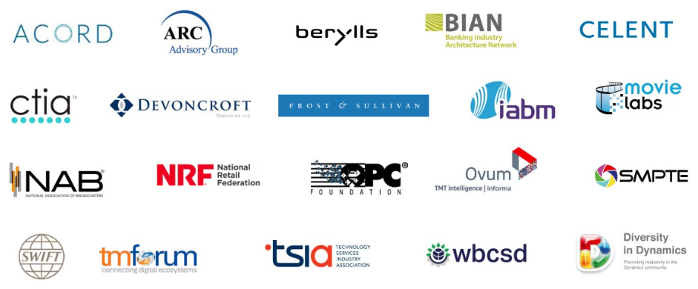

Find out more about how to leverage Technology Record
Contact us about the wealth of marketing opportunities available to Microsoft partners looking to promote their brand:

Executive editor: Andy Clayton-Smith - andy@technologyrecord.com

Advertising and sponsorship: Ricky Popat - ricky.popat@technologyrecord.com

Further information
Technology Record is published quarterly by Tudor Rose. To find out more or to view back issues visit www.technologyrecord.com. This editorial plan is subject to the availability of those organisations and individuals listed. Alternative contributors will be found wherever possible.

