Editorial highlights
Technology Record: Issue 43 – Winter 2026

Last editorial contribution date: 12 November 2026
Publication date: 21 December 2026

Upfront
A round-up of technology innovation and business wins from Microsoft and its ecosystem of partners. In this issue we also take time to focus upon Ignite 2026, with our views on some of the best strategies, solutions, and services presented at this year’s gathering in San Francisco.

In conversation with
As part of our ongoing series of interviews with senior leaders at Microsoft, we talk with president of the recently created Microsoft Frontier Company, Rodrigo Kede Lima, about redefining productivity, and reshaping work across every industry and region.

Cover story
Developing new and sustainable markets for all
The rapid uptake of AI is already having profound impacts upon global economies, by allowing business and civic leaders to reimagine their operating landscapes and accelerate their innovation at a rate faster than ever witnessed before. At the same time, however, the ever-increasing pace at which technology is being leveraged has potential to disrupt organisational control and put real strain upon the infrastructures and communities that have evolved around more traditional workflows. So how are organisations from all sectors successfully embracing change that will augment rather than disrupt their day-to-day operations, and present new opportunities that are both sustainable and dependable? We take a closer look in the Winter 2026 issue of Technology Record.
- Microsoft spokesperson: Matthew Kerner, CVP and chief technical officer, worldwide sales and solutions [to be confirmed].

In focus
Increasing the value of Microsoft Teams through constant evolution
It’s safe to say that Microsoft Teams has already claimed its place in the pantheon of leading collaboration platforms, and arguably it can now be seen as the default communication solution for all global enterprises. With a raft of AI-powered enhancements being rolled-out by Microsoft toward the end of 2026 and onwards into early 2027, customers are likely to find this near-ubiquitous business tool becoming entirely central to the way in which workers connect with colleagues, partners, suppliers, and customers. In our annual Teams update we spend time talking with Microsoft’s global vice president for Teams calling, devices, and premium experiences, about advances made through the past twelve months and the innovation we can expect to see in the coming year.
- Microsoft spokesperson: Ilya Bukshteyn, VP Teams calling, devices and premium experiences [to be confirmed].
Financial Services
Powering workforce enablement in FSI
For most in financial services, conversations about workforce enablement are no longer focussed solely upon productivity but instead have grown to include new demands for operational efficiency, compliance, security, and an ever-growing requirement to deliver positive customer outcomes. Automating what were traditionally manual operations by integrating technology tools has already reaped rewards and, as the power of agentic AI grows, so the opportunities to extend the range of workers whilst freeing them from more mundane administrative tasks will increase. So how will agents and operators happily coexist? Technology Record finds out more.
- Microsoft spokesperson: Uzair Hussain, managing director and senior banking strategy advisor.

Industrials and Manufacturing
Empowering personnel across the manufacturing enterprise
Despite an increasing focus upon the commercial potential of generative AI tools, traditional workforces still lie at the heart of a manufacturer’s ability to deliver product. That being the case, the role of technology should be to empower workers rather than replace them, which is why Microsoft and its ecosystem of manufacturing partners are focussed upon helping workers to become more connected and productive. Microsoft Azure cloud and AI tools like Copilot are helping employees to analyse information faster, reduce operational downtime, and manage complex industrial processes more efficiently.
- Microsoft spokesperson: Parag Ladha, global industry marketing director, manufacturing.

Media and Communications
Autonomous networking is changing the way businesses run and operators succeed
The arrival of generative AI in the telecommunications industry is changing the way in which networks operate. Growth in modern networks is accelerating, along with pressure for traditional operations to keep up with a rapidly evolving telco landscape. For growing numbers of operators, AI-powered workflows and autonomous AI agents are making it possible to diagnose issues and resolve problems at speed, all without increasing existing workforce numbers. Growing collaboration between human operators and AI systems is changing the way networks function, as we find out in our latest issue.
- Microsoft spokesperson: Rick Lievano, CTO, worldwide telecommunications industry.

Public Sector
Protecting public data and securing continuity of services
In a world where data is constantly under threat of exposure and technology outages, accidental or otherwise, all too easily impact upon essential services, where can civic leaders find help to secure the information they hold and maintain services that citizens rely upon so heavily? For many, the answer lies in the family of AI-enabled tools which Microsoft and its public sector partner community are bringing to market. From helping organisations to protect citizen data to ensuring continuity of essential services through resilient cloud infrastructure and AI-powered operations, the options are compelling.
- Microsoft spokesperson: John Doyle, head of global marketing, government, defence and intelligence.

Retail and Consumer Goods
Beyond digital: How AI and partnerships are redefining retail and consumer goods
As margins tighten and labour remains scarce, the next competitive reset will not happen in dashboards but on the physical edge. After a decade of digitising, planning, and leveraging analytics tools, retailers now face structural volatility, rising service expectation, and an unreliable workforce availability. Incremental forecasting gains are no longer enough. By connecting cloud intelligence to execution on the shop floor and in the aisle, Physical AI enables operations to run with software-like speed, resilience, and discipline, reshaping cost-to-serve metrics and service performance.
- Microsoft spokespeople: Felice Miller, global business strategy lead, retail and consumer goods / ShiSh Shridhar, global director, retail and consumer packaged goods start-ups.

The last word
Commentary on a digitally transformed world from Technology Record, along with opinions from leading industry analysts and associations.

Event partnership
Throughout the year Technology Record maintains strategic links and a physical presence for both publication and personnel at a number of leading in-person industry events. At the same time, the magazine supports and augments virtual gatherings with digital promotion and online coverage.

Winter 2026 events:
NRF 11 – 13 Jan 2027, New York City | ARC Forum 22 – 25 Feb 2027, Orlando
ISE 2 – 5 Feb 2027, Barcelona | MWC Barcelona 1 – 4 Mar 2027, Barcelona
Tech Expo 3 – 4 Feb 2027, London | FABCON 8 – 12 Mar 2027, Atlanta
EuroCIS 16 – 18 Feb 2027, Dusseldorf | Enterprise Connect 23 – 25 Mar 2027, Las Vegas

Alliances
Technology Record is proud to partner with a broad range of leading industry organisations including:

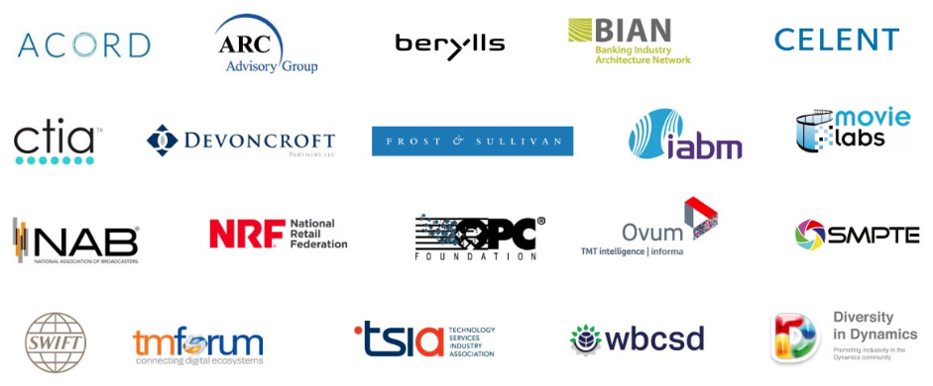

Find out more about how to leverage Technology Record
Contact us about the wealth of marketing opportunities available to Microsoft partners looking to promote their brand:

Executive editor: Andy Clayton-Smith - andy@technologyrecord.com

Advertising sales enquiries: Ricky Popat - ricky.popat@technologyrecord.com.

Further information
Technology Record is published quarterly by Tudor Rose. This editorial plan is subject to the availability of those organisations and individuals listed. Alternative contributors will be found wherever possible.

