Editorial Highlights
Technology Record: Issue 29 – Summer 2023

Publication date: 20 June 2023
Last editorial contribution date: 22 May 2023

Upfront
A round-up of all the latest technology trends, innovations, business wins and product releases from Microsoft and its global ecosystem of partners.
Cover story
Feature: Successfully driving change in modern workforce culture
Research from Microsoft shows that an increase in ‘telecommuting’ workers of around 22 per cent between 2017 and 2018 increased three-fold during the pandemic. As organisations now cope with economic turbulence, growing numbers are adapting existing workforce strategies to embrace more modern ways of operating. The benefits of adopting secure, cloud-based technology tools are tangible, not only in terms of worker retention and operational efficiency but also in leveraging entirely new markets. With analyst group IDC predicting some $6.8 trillion in digital investments between 2020 and the end of 2023, solutions from Microsoft and its ecosystem of partners are helping drive worker productivity and collaboration across multiple platforms and locations.
- Microsoft spokesperson: To be confirmed.

Microsoft product focus
Feature: Revolutionising operational efficiency with the Teams platform
The last few years saw disruption to every facet of daily living, not least in the workplace, where staff found themselves isolated from teammates and customers, struggling to collectively keep their companies afloat. Supply chains across all industries were thrown into turmoil and traditional operating strategies became difficult, if not impossible, to maintain. For many, the Microsoft 365 suite of products and, in particular, its flagship collaboration tool Teams rapidly became the de-facto way to maintain effective links between workers, suppliers, partners and customers. As the threat of global pandemic recedes, growing numbers of organisations are taking lessons learned during this uniquely challenging period to enrich core operations with newly adopted hardware, tools and procedures. We find out more about the impact Microsoft Teams has had on enterprise and public sector operations.
- Microsoft spokesperson: Abid Chaudhry, product marketing director, frontline & industry, Microsoft 365 & Teams.

Financial Services
Feature: Governance, compliance and risk in financial services
Moving to the cloud offers all businesses a huge opportunity to access new markets; however, within the financial services industry there is an additional requirement to drive innovation whilst adhering to a wide range of regulatory requirements. Products such as the Microsoft Cloud for Financial Services are actively helping businesses to compete and win business in a compliant and secure manner. Technology Record finds out how.
- Microsoft spokesperson: Dave Dadoun, managing director, global strategy and compliance.

Industrials & Manufacturing
Feature: Drive sustainability through cloud-powered supply chains
Modern consumers increasingly demand that brands offer clear sustainability credentials. The race is on to deliver tangible environmental, social and governance (ESG) standards and, in manufacturing, these strategies centre largely around the supply chain. Accurately gauging consumption of raw materials whilst also measuring the production impact upon emissions and waste are key factors in any manufacturing operation, leading many businesses to utilise technology in powering their sustainability story. Technology Record investigates further.
- Microsoft spokesperson: To be confirmed.

Media & Communications
Round table: What will the media industry look like in 2030?
Technology Record brings together a number of key media organisations to makes predictions upon how emerging Microsoft technology will lay the foundations for further evolution of the industry landscape. Marvel, Paramount, Microsoft, and other media industry luminaries tell us more about the challenges and opportunities ahead.
- Microsoft spokesperson: Simon Crownshaw, worldwide strategy director - media and entertainment.

Public Sector
Feature: Creating social, economic and environmental prosperity
Civic leaders around the world are alive to the concept of more holistic approaches to public sector service provision. Whether considering the built infrastructure, public transit, the delivery of healthcare and education services, ensuring safer communities through policing and security, or supporting commerce to drive more successful economic outcomes, government leaders are learning to adopt longer-term planning strategies that embrace technology as a driver for change. Technology Record takes a closer look at latest innovations.
- Microsoft spokesperson: To be confirmed.

Retail and Consumer Goods
Feature: Powering revenue growth management in consumer goods
Consumer-goods industry leaders have learned to master the fundamentals of revenue growth management with brands, pricing, promotion, and investment playing key roles in strategy planning. In challenging economic times, many within the sector are struggling to maintain market share and looking to boost competitive advantage by adopting innovative technology tools. Microsoft’s Cloud for Retail is one of the toolsets helping consumer-goods specialists to succeed in tough times.
- Microsoft spokespeople: Dina Zhou, executive director, industry digital strategy, retail and consumer goods / Irving Lee, global lead, retail and consumer goods strategies.

The last word
Analysis: Industry analyst commentary on innovation in a digitally transformed world.

Event partnership
Throughout the year Technology Record maintains strategic links and a physical presence for both publication and personnel at a number of leading in-person industry events. At the same time, the magazine supports and augments virtual gatherings with digital promotion and online coverage.

Summer 2023 events:
- eTail 2023, 14-16 August, Boston
- EduTech 2023, 24-25 August, Melbourne.
- IBC 2023, 15-18 September, Amsterdam
- Sibos 2023, 18 – 21 September, Toronto.

Alliances
Technology Record is proud to partner with a broad range of leading industry organisations:
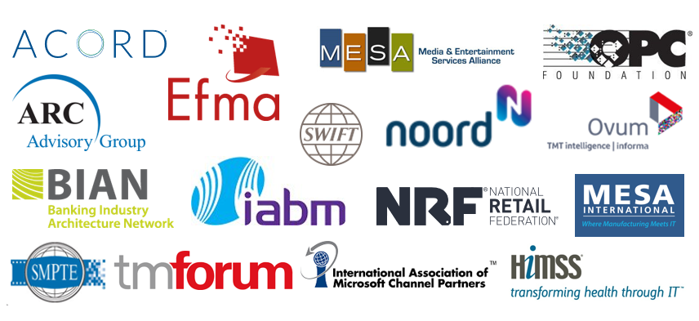

Talk with one of our dedicated industry leads
We are happy to talk with you about forthcoming editorial planning and the wealth of marketing opportunities which are available to Microsoft partners wishing to promote their brand.

Financial Services: Ricky Popat - ricky.popat@technologyrecord.com
Industrials and Manufacturing: Daniel Thurlow - daniel.thurlow@technologyrecord.com
Media & Communications: Tim Grayson - tim.grayson@technologyrecord.com
Public Sector: Paul Zmija - paul.zmija@technologyrecord.com
Retail & Consumer Goods: Thomas Wills - thomas.wills@technologyrecord.com.

Executive editor: Andy Clayton-Smith - andy@technologyrecord.com

Further information
Technology Record is published quarterly by Tudor Rose. To find out more or to view back issues visit www.technologyrecord.com. This editorial plan is subject to the availability of those organisations and individuals listed. Alternative contributors will be found wherever possible.

Find out more at https://www.technologyrecord.com/contact-us.

